April 1, 2021

Dear Parent or Guardian:

Effective July 1, 2021, children 16 years of age and older, who are entering the 11th grade (including new entrants), must have received one booster dose of the meningococcal conjugate vaccine (MCV4), unless their initial dose was administered on or after their 16th birthday.
Meningococcal disease is a serious bacterial illness that affects the brain and the spinal cord. Meningitis can cause shock, coma and death within hours of the first symptoms.
If your teen has not been vaccinated against meningococcal disease, we strongly recommend getting your 11th grader, aged 16 years or older, vaccinated before starting the 2021-2022 school year. Getting MCV4 (meningococcal conjugate vaccine) now will not only help protect your child against the ongoing threat of meningitis, it will also meet the new school entry requirement.
Ask your pediatrician or local health department about other shots your child may need including:
- the human papillomavirus (HPV) series
- the tetanus, diphtheria, pertussis shot (Tdap or Td booster)
- an annual flu vaccine; and
- catch-up immunizations, including chickenpox, MMR (measles, mumps, rubella) and hepatitis B.

If your child does not have health insurance or their health plan won’t cover these vaccines, call your local health department and ask about getting no cost or low cost vaccines. For more information, visit http://dph.georgia.gov/vaccines-children or call (800) 848-3868.

Sincerely,
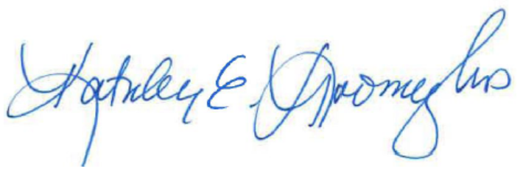
Kathleen E. Toomey, M.D., M.P.H.
Commissioner & State Health Officer

